Title: **Wildlife Responses to Non-Motorized Recreation in the Southern Canadian Rockies: A Multi‑Scale Analysis near Fernie, BC**

Running head: **Fernie Rec Paper**

Clayton T. Lamb1,2*

Emily Chow3

**Affiliations**

1 University of British Columbia, Department of Biology, Kelowna, BC, Canada, V1V 1V7

2Wildlife Science Center, Biodiversity Pathways, Kelowna, BC, Canada, V1V 1V7

3Ministry of Water, Lands, and Resource Stewardship, Cranbrook, BC

*Corresponding author: ctlamb@ualberta.ca

**Data availability**

The code and data to reproduce this analysis is deposited at the following github: XXX

The photos and species classifications from the Fernie Trail Network data are publicly accessible at the following links (each year of data is its own link):

https://portal.wildtrax.ca/home/camera-deployments.html?sensorId=CAM&projectId=998

https://portal.wildtrax.ca/home/camera-deployments.html?sensorId=CAM&projectId=1401

<https://portal.wildtrax.ca/home/camera-deployments.html?sensorId=CAM&projectId=1971>

https://portal.wildtrax.ca/home/camera-deployments.html?sensorId=CAM&projectId=2626

**Keywords:**

trail use, Ursus arctos, Cervus canadensis, camera trap, GPS telemetry, iSSA, non-motorized recreation, habitat selection, mountain bike, tourism

**Abstract**

Outdoor recreation is expanding across natural landscapes, yet its effects on wildlife remain poorly understood across spatial and temporal scales and across different contexts. We assessed the responses of large mammals to non-motorized recreation near Fernie, British Columbia, using a multi-scale observational approach combining data from 66 camera traps and GPS telemetry from 21 grizzly bears (*Ursus arctos*). We evaluated (1) how wildlife detections varied by trail type, relative to the broader landscape, and with varying level of recreational users, and (2) whether animals shifted activity to avoid peak human use, and (3) how collared grizzly bear movement responded to recreation compared to other anthropogenic features. Trail context significantly influenced detection probabilities, but responses varied by species and scales. Elk (*Cervus canadensis*) showed the strongest avoidance, with reduced presence on recreation trails (OR ≈ 0.37, *p* ≈ 0.002) and a marked shift toward low-use periods (Δoverlap = –0.24). In contrast, moose (*Alces alces*) and mule deer (*Odocoileus hemionus*) were more frequently detected on or near moderately used trails. Grizzly bears consistently avoided trail-adjacent areas in GPS movement data and camera detections but were detected on recreation trails more than adjacent wildlife trails suggesting when they do use move through the trail network they do so on recreation trails. These findings highlight species- and scale-dependent responses, with effects ranging from strong (elk), to moderate (grizzly bears), to minimal (black bears, moose, mule deer, red fox, and white-tailed deer). Our results suggest that concentrating recreation near existing developed areas and during mid day should minimize impacts on wildlife while providing important access to recreation for people. Maintaining low-use zones elsewhere will be important for more sensitive species. While observational studies like ours are valuable for identifying patterns and informing management of rapidly changing pressures, stronger inference through experimental designs is encouraged to clarify causal relationships between recreation and wildlife behavior and further elucidate species- and context- dependent relationships.

**Introduction**

Humans have long shaped the distribution and abundance of wildlife through habitat alteration and direct mortality. Road networks fragment habitat and cause vehicle collisions (Forman and Alexander 1998), human presence and persecution has reduced or eliminated species from large portions of their former ranges(Laliberte and Ripple 2004). While these negative effects are well documented and intensifying in many regions, it is also true that people and wildlife have coexisted on Earth for millennia. Multiple examples exist where ecosystems co-evolved with human interaction and have suffered when human use has been excluded, as has been the case with the exclusion of cultural and prescribed fire from dry montane forests in North America during the 20th century (Greene 2021). Even under contemporary pressures, there remain landscapes—some densely populated—where large mammal communities persist with remarkable continuity (Laliberte & Ripple, 2004). This paradox underscores a central challenge in conservation biology: understanding the conditions under which wildlife can persist and even thrive in contemporary human-dominated environments.

Just as wildlife depend on access to natural habitats, humans increasingly seek those same landscapes for health, well-being, and recreation. Time spent in nature has been linked to improved physical and mental health, enhanced cognitive function, and greater social cohesion (Bratman et al. 2019). Outdoor recreation offers the dual benefits of time in nature paired with cardiovascular exercise (Thomsen et al. 2018). As participation in outdoor recreation grows, so too does the spatial extent of recreational use—particularly in mountainous and forested regions. This expansion raises pressing questions about how human presence influences wildlife, and how these landscapes can be stewarded to sustain both biodiversity and public access. Land managers, recreation planners, and policymakers are increasingly seeking science-based guidance to help anticipate, mitigate, or avoid unintended impacts on sensitive species (Miller et al. 2020, Jordan et al. 2025).

Recreation ecology—the study of recreational impacts on ecological systems—has expanded rapidly to meet this need (Monz et al. 2013). Yet its findings remain mixed. Some studies report strong negative effects on wildlife, such as spatial displacement, increased energy expenditure, reduced reproductive success, or elevated mortality risk (Wiedmann and Bleich 2014, Urhan et al. 2025). Others document minimal or even positive responses, including behavioral habituation (Miller et al. 2020, Granados et al. 2023) or the use of human-modified areas as refuges from predators or hunting pressure(Berger 2007). These variable responses tend to depend on species’ sensitivity, landscape context, and the type, timing, and intensity of recreation(Naidoo and Burton 2020, Procko et al. 2022). This heterogeneity of outcomes poses a challenge for managers: the empirical record is often context-dependent and difficult to generalize without appropriate consideration of species, landscape, activity type, and scale.

Among the most informative studies are those that employ experimental or quasi-experimental designs, such as before–after–control–impact (BACI) frameworks or manipulative trail closures. For example, (Miller et al. 2020) conducted a BACI study around a new unpaved recreational trail being built in an Appalachian protected area, focusing on responses from white-tailed deer, coyotes, raccoons, and gray squirrels. Their results showed that overall species decreased use of the area during trail building but returned to baseline detection levels once construction was complete and humans were using the trail, albeit at low rates (1.4 visitors per day). Notably, control sites helped decouple population fluctuations from experimental effects that would have obscured results in even a traditional before-after experiment. Contrary to Millers results, (Wiedmann and Bleich 2014) assessed bighorn sheep responses to a recreation hiking trail built in western North Dakota, USA that had higher rates of use. Although not stated in the paper, in 2016 the trail apparently saw >15,000 users a year, or >40 per day. They document sheep displacement, lower recruitment, population decline, and eventual abandonment of lambing areas for one subpopulation. However, three other subpopulations of sheep were exposed to the trail at lower intensities and with more consistent human use, and these populations showed no negative effects from the trail and increased in size. Experimental perturbations of elk and mule deer at the Starkey Experimental Forest suggested recreationist displaced elk by >500 meters and recreation reduced the time elk fed or rested and increased the time they were travelling (Wisdom et al. 2018, 2018). Recreation effects on elk were greatest for ATV riding and moderate from bikes, hikers, and horseback riders. Similar experiments on mule deer at Starkey Experimental Forest did not produce strong effects (Wisdom 2005). Finally, (Costello et al. 2013) assessed GPS collared black bear responses to the development of a non-motorized trail alongside an existing road. At least 100 people were using the trail per day but there was no detectable change in bear home range or frequency of crossing the corridor. Bears did alter their 3rd order selection near the corridor and shifted to more nocturnal behaviour.

Even strong inference from experimental studies suggest recreational effects can and will vary by recreational type, intensity, predictability and wildlife species. Such context dependent responses are perhaps something that wildlife managers will have to accept, and thus the more information that can be generated on how these different contexts scale up to impact wildlife behaviour and demography at local and broader scales will allow for better evidence-based management. Importantly, experimental approaches can isolate causal effects but are logistically and ethically constrained, especially in high-use or multi-jurisdictional areas. As a result, well-designed observational studies remain an important part of knowledge generation, particularly when paired with complementary data sources such as telemetry or high-resolution camera monitoring.

Scale is also critical to recreation ecology inquiry. Johnson's (1980) hierarchical framework of habitat selection emphasizes that animals respond to their environment at multiple levels: the placement of home ranges within the landscape (second-order selection), the use of habitats within those home ranges (third-order), and fine-scale behavioral decisions (fourth-order). Recreational activity can influence wildlife at all these scales. Animals may avoid regions with high recreation altogether (Wiedmann and Bleich 2014), reduce use of areas near trails and infrastructure within their home range (Whittington et al. 2022), or shift activity to less disturbed times of day (Gaynor et al. 2018). Accurately capturing such responses requires models and datasets that are sensitive to variation in both space and time.

In this study, we examine how a community of large mammals responds to outdoor recreation in the southern Canadian Rockies near Fernie, British Columbia. We addressed four core questions: (1) Intensity of use: How do wildlife detections vary in areas of intense recreational use relative to the surrounding landscape and how do different levels of recreational use on recreation trails influence detections? (2) Diel patterns: For animals present in the trail network, do they adjust the timing of their trail use to minimize overlap with recreational users and how does this compare to behaviour observed across the landscape? (3) Grizzly bear movement: How do GPS‑collared grizzly bears modify their movement and habitat selection in relation to trail proximity and recreation intensity? (4) Near encounters: what is the risk of human-wildlife conflict between bikes and potentially dangerous animals such as bear or moose on wildlife trails. We hypothesized that if recreation was having strong and consistent negative effects that wildlife would be detected at lower rates in areas near trails due to animals avoiding the areas with high human disturbance. Within the trail network We hypothesized that wildlife would use recreation trails used by recreationist less than nearby wildlife trails, and they would prefer to use recreation trails with lower recreational use. We hypothesized that wildlife would temporally avoid the peak times of day people are active on the trails but use these times more in areas with fewer people. We hypothesized that grizzly bears would strongly avoid the trail network, and this avoidance would be similar in magnitude to other high impact disturbances such as towns and the highway. Finally, we hypothesized that the overall avoidance of the recreationist would mean there were few near encounters between recreationists and potentially dangerous wildlife. To answer these questions, we combined multi‑year camera‑trap monitoring integrated step selection analysis of grizzly bear telemetry. This multi‑stream approach allowed us to assess patterns of avoidance, co‑use, and scale‑dependent sensitivity to recreation activity.

**Methods**

*Study Area*

We conducted our study in the forested mountain landscape surrounding Fernie, British Columbia (49.5°N, 115.1°W), a city of 6,320 residents as of the 2021 Census . Situated in the Elk Valley of southeastern British Columbia, Fernie lies along the Elk River and is encircled by the Rocky Mountains, including the Lizard Range and Three Sisters peaks (Figure 1). The region encompasses a broad elevation gradient (900–2,400 m) and features diverse forest types, including montane and subalpine coniferous stands dominated by Douglas-fir (*Pseudotsuga menziesii*), lodgepole pine (*Pinus contorta*), Engelmann spruce (*Picea engelmannii*), and subalpine fir (*Abies lasiocarpa*). Riparian zones along the Elk River and its tributaries support black cottonwood (*Populus trichocarpa*) communities, notably within the Ancient Cottonwood Trail near Fernie, which contains some of the oldest known black cottonwood trees in the region.

Fernie is accessible via Highway 3 (Crowsnest Highway), a major east-west transportation corridor traversing southern British Columbia and connecting to Alberta through the Crowsnest Pass . The area supports a diverse assemblage of large mammals, including grizzly bears (*Ursus arctos*), black bears (*U. americanus*), cougars (*Puma concolor*), wolves (*Canis lupus*), elk (*Cervus canadensis*), and mule and white-tailed deer (*Odocoileus spp.*). A dense, year-round network of recreational trails—used by hikers, bikers, backcountry skiers, and motorized users—overlays this habitat, primarily on provincial Crown land but also on private land accessible to the public.

*Camera Traps*

We deployed remote cameras (Reconyx Hyperfire 2) throughout the recreational trail network on Mount Fernie and Mount Proctor (Figure 1). Cameras were set on a tree 1.5 meters above the ground and 6-10 meters from the trail. Any vegetation that would interfere with detection on the trail was removed each year in the spring or summer.

We monitored human and wildlife use on two types of trails, 1) single and double track bike and hiking trails (n=18) , and 2) adjacent wildlife trails within 500 meters of trails (n=10). Cameras were programmed to take 5 photos at each detection on high sensitivity, with <1 second (rapid-fire setting) between images. No delay between subsequent detections were set, essentially meaning the camera took as many photos as fast as it could while there was detectable movement in its’ view. A timelapse photo was set to be taken at 12:00 pm daily to denote the period the camera was operating. The cameras were checked 2-10 times a year and were present year-round from May 2021- November 2024.

We uploaded images to WildTrax (https://wildtrax.ca/), a cloud-based camera trap data management platform. The MegaDetector software (Beery et al. 2019) is automatically run within WildTrax to remove high likelihood empty photos as well as humans and vehicles, increasing the efficiency of downstream image processing (Fennell et al. 2022). A team of image taggers from the Alberta Biodiversity Monitoring Institute manually verified species tags in each image and classified images without species tags from the MegaDetector. For each image the number of each wildlife species present in the image was recorded. We did not count the number of humans present in each image due to the volume of photos, and rather just tagged to the type of human use- bike, vehicle, off-road vehicle, heavy machinery, or human (typically a hiker or runner). Initially we classified domestic dogs along with hikers and bikers on the trails. Dogs were present at high rates and we didn’t expect that there would be sufficient variation in dog absence or presence with recreationists to assess dog effects, thus we stopped tagging dogs in 2022 to reduce costs and do not conduct any analyses on domestic dogs.

In addition to the camera traps specifically deployed for this project, we also used cameras from neighbouring projects near Fernie to gain a broader landscape perspective (Figure 1). These cameras were dispersed through the Elk and adjacent river valleys as well as high elevation areas. While these cameras were deployed on a variety of trail types, we only used the cameras deployed on wildlife trails. We broke these landscape-level cameras into two groups. The “landscape-valley” group was within 25 km of Fernie and in similar habitats to the Fernie recreation cameras (n=21), which were typically Interior Cedar Hemlock or Montane Spruce zones. The landscape-valley cameras were in areas that also had highways, railways, towns, and resource roads but less recreational use than the Fernie trail network and thus provided a comparison with insight into the additive effect of the trail network on wildlife detections and behaviour. The second group, landscape-remote, were in more remote and higher elevation habitats than the Fernie trail network (n=17). Because the habitat of the landscape-remote cameras was not as comparable with the Fernie trail network we used these cameras for temporal (diel) comparisons only but not intensity of use. All cameras were Reconyx, although a variety of Reconyx models were used (HP2X, Hyperfire PC600-900). We included the camera model in our models to account for detectability differences. Details on these landscape-level camera projects can be found in the following publications (Granados et al. 2023, Lamb 2025a, 2025b, Lamb et al. 2025), Figure 1).

*Camera Statistical Analysis*

From the classified images, we created several datasets for the following analyses. We subset the camera data to the period between May 1 and October 31 each year to focus on the snow-free season, when wildlife were consistently present across the landscape. This period also corresponded with peak non-motorized recreational activity around Fernie*.* During the winter months many migratory ungulates left the area and bears were hibernating (Lamb et al. 2022, Poole et al. 2024). Recreation use was low in winter on most trails except those groomed for winter biking and cross-country skiing.

*Intensity of use*—We generated a detection dataset by collapsing consecutive photos of the same species into single detection events if separated by less than ten minutes. This approach likely underestimates the true number of recreationists detected as many individuals or groups may pass in 10-minute window. These detections were compiled for each species at each camera. We assessed how average monthly detection rates varied by area (Rec trails and wildlife trails in the Fernie trail network and the Landscape-valley cameras outside the Fernie trail network) using generalized linear mixed models. To account for the abundance of months with no detections, we used a hurdle-model approach where we first modelled presence-absence using a binomial model with logit link for each species per month and then a second model where animals were detected we used a truncated Poisson distribution to model the detection rate (relative abundance). For each model we included random intercepts for camera model, month, year, and camera ID. We also assessed if additional environmental variables were appropriate to include to remove environmental variation between the camera projects that could interfere with our comparisons. For each species we compared whether inclusion of indices of habitat productivity (annual precipitation or summer enhanced vegetation index) improved the fit of data to the model via AIC. In cases where these covariates improved model fit, we included the covariates in their final model models.

Within the Fernie trail network, we assessed how wildlife detection rates were influenced by the number of recreational users on the recreation trails. We conducted this analysis at a weekly interval to detect finer-scale responses of wildlife to changing recreation pressure. To account differences between trail locations we included measures of canopy cover, slope, summer enhanced vegetation index, and distance to building for each camera. We used the hurdle model structure as above to model presence and then relative abundance based on the number of recreational users on the trails. We included random effects for week of the year, year, and camera ID. No random effect for camera model was included because the cameras were all the same model in this analysis.

*Diel patterns–*In addition to comparing detection rates across space, we analyzed temporal variation in response to human recreation by summarizing daily diel overlap between people and wildlife across trail types. We assessed diel patterns using detection histograms and calculated coefficients of temporal overlap (Δ) to quantify behavioral displacement of wildlife from people on recreation trails, adjacent wildlife trails, and the wildlife trails across the broader landscape. People were primarily only detected on recreational trails and thus we compared the use of wildlife during this period of high human use on the recreation trails to assess if animals not facing this same level of human use still avoid these times or not.

*Near encounters–* To quantify how often large mammals were detected soon before or after recreationists, we paired every biker and hiker detection on single-track trails with all detections of black bears, grizzly bears, or moose at the same camera. We selected these animals are they are the primary species that can be dangerous to people and were frequently detected in the trail network. We then kept only the closest-in-time wildlife detection for each species and recreation event. We calculated the time difference in minutes and summarized how often wildlife detections occurred within 30 minutes and within 5 minutes of people. We visualized these “near encounters” by species and recreation type.

*Collared Grizzly Bears*

Grizzly bears were collared throughout the Elk Valley between 2016-2024 as part of a study to assess population demography (Lamb et al. 2023). Although the study goal was not to assess recreational impacts on bear behaviour, we are able to leverage these data as part of our multi-lines of inference approach here given the abundance of grizzly bear telemetry around Fernie. Full details on the grizzly bear capture and handling and relevant permits are summarized in (Lamb et al. 2023), but briefly the bears we considered here were collared with Vectronics Vertex Lite GPS collars programmed to take locations every 2 hours during the active season for grizzly bears (April to December). The data was transmitted via Iridium satellite. We collared all age and sex classes except animals <2 years of age due to challenges fitting collars to these rapidly growing young bears. For this analysis we used location data for bears with at least 50 locations within 10 km of Fernie between May 1-October 31 across years.

*Grizzly Bear Integrated Step Selection Analysis*

We used integrated step selection analysis (iSSA) to evaluate how large mammals respond to human recreation and habitat features in the Fernie region of British Columbia (Avgar et al. 2016). Step selection functions were implemented using conditional Poisson regression with random effects, which is mathematically equivalent to conditional logistic regression but enables more flexible estimation of random slopes and intercepts using generalized linear mixed models (GLMMs) (Muff et al. 2020).

For each GPS-collared animal, observed steps were paired with a set of random available steps drawn from the empirical step length and turn angle distribution, forming matched strata of one “used” and ten “available” steps. We then fit iSSA models using the glmmTMB package (v1.1.7) in R, with a binary response variable (where 1 = used step and 0 = available), family = poisson, and a random intercept for each stratum ((1 | stratum)) to condition the analysis within each matched set.

The fixed effects structure included habitat covariates (e.g., land cover type, elevation, summer greenness [EVI]), topographic complexity (TRI), and several measures of anthropogenic influence, including distance to trail, highway, and rural development, as well as semipermeable barrier effects. Movement covariates included step length (log-transformed), turn angle (cosine), and their interaction (e.g., cos_ta:log_sl_km) to capture behavioral state transitions. We also included habitat-by-movement interactions (e.g., cos_ta:dist_to_trail) to allow for context-dependent movement decisions.

To account for variation in selection across individuals and seasons, we included random slopes by individual ((0 + covariate | id)) for key habitat, movement, and barrier variables, and a random slope for elevation by month to account for seasonal effects ((0 + elevation_end | month)). All continuous covariates were standardized prior to modeling to facilitate convergence and comparability of coefficients.

We used a candidate model approach to evaluate how outdoor recreation and environmental covariates influenced step selection by wildlife. We began with a core set of ecological and movement covariates and iteratively added disturbance and barrier terms to construct biologically plausible models. Each candidate model was evaluated using Akaike’s Information Criterion (AIC), and the top model was selected based on parsimony and fit.

To assess model stability and performance, we examined predicted values to ensure no extreme or implausible outputs and checked for convergence warnings. Due to the structure of iSSA data—particularly the large number of strata and design-imposed zeros—we did not use residual simulation tools such as DHARMa, which are known to perform poorly under these conditions.

**Results**

*Camera Traps*

Cameras operated in the Fernie trail network for 13, 698 trap nights between May 1, 2021 and October 31, 2024 and captured 1,739,387 images. After removing empty images and classifying unique detections (images 10 minutes apart) there were 98,499 detections. Of these detections, 88,558 were of people, 43 of domestic species, and 9,451 were of wildlife (Table 1). Mountain bikers were the most detected recreational group on the cameras. White-tailed and mule deer were the most detected wildlife. Several species were detected at low rates (<30 detections) such as bobcats, badgers, wolverine, and a mountain goat and were not used in subsequent analyses due to their rarity. We focus our analyses on 7 large/medium mammal species with > 30 detections each (white-tailed deer, mule deer, elk, red fox, moose, black bear, and grizzly bear).

Table 1. Summary of detections by species at Fernie Trail Network cameras between May and October each year between 2021-2024

|  |  |  |  |  |  |
| --- | --- | --- | --- | --- | --- |
| **Group** | **Species** | **Sites** | **Detections** | **Hit rate per 100 days** | |
| Human | bike | 19 | 73346 | 535.5 |
| Human | human | 28 | 14666 | 107.1 |
| Human | all terrain vehicle | 8 | 286 | 2.1 |
| Human | vehicle | 5 | 242 | 1.8 |
| Human | heavy equipment | 2 | 18 | 0.1 |
| Wild | white-tailed deer | 28 | 3611 | 32.6 |
| Wild | mule deer | 27 | 2008 | 17.9 |
| Wild | elk | 27 | 1382 | 13.4 |
| Wild | red fox | 22 | 908 | 6.7 |
| Wild | moose | 26 | 670 | 5.7 |
| Wild | black bear | 28 | 464 | 3.8 |
| Wild | deer | 24 | 141 | 1.1 |
| Wild | grizzly bear | 20 | 101 | 1 |
| Wild | snowshoe hare | 7 | 85 | 0.6 |
| Wild | gray wolf | 11 | 22 | 0.2 |
| Wild | cougar | 9 | 14 | 0.1 |
| Wild | bird | 9 | 13 | 0.1 |
| Wild | coyote | 8 | 10 | 0.1 |
| Wild | porcupine | 6 | 7 | 0.1 |

*Camera Statistical Analysis*

*Intensity of use*—Across species, trail context influenced detection probabilities and relative abundance, but effects varied by species and by model component (presence vs. abundance). Trail contrasts were assessed both between the Mt. Fernie trail network and the broader valley, and within the trail network (wildlife vs. recreational single-track, Figure 2).

Humans and bikers were overwhelmingly detected on single-track (Rec) trails. Both presence and abundance given presence were significantly higher in the Mt. Fernie trail network compared to valley sites (human presence OR ≈ 0.008, p < 0.001; abundance ratio ≈ 0.13, p < 0.001). Within the trail network, detections were strongly concentrated on Rec trails (presence OR ≈ 0.0016, p < 0.001; abundance ratio ≈ 0.016 for wildlife vs. Rec, p < 0.001).

Black bears showed significantly higher presence on wildlife trails than in the valley (OR ≈ 3.4, p ≈ 0.016). Presence was also higher in the trail network overall compared to the valley (OR ≈ 3.6, p ≈ 0.022), but abundance did not differ significantly across contexts. Elk occurred more frequently and were more abundant in valley sites than in the Mt. Fernie trail network (presence OR ≈ 15.1, p ≈ 0.036). Within the trail network, they were more likely to occur on wildlife trails than Rec trails (OR ≈ 2.7, p ≈ 0.065), consistent with the near-zero detections on Rec trails. Grizzly bears were detected infrequently, but trail context affected their probability of occurrence. Presence was significantly lower on wildlife trails than in the valley (OR ≈ 3.8, p ≈ 0.023), and higher on wildlife trails than Rec trails (OR ≈ 0.21, p ≈ 0.001). The overall difference in presence between valley sites and the Mt. Fernie trail network was not significant (OR ≈ 1.76, p = ns). Abundance was marginally higher in the valley than in the trail network (abundance ratio ≈ 0.32 for trail vs. valley, p ≈ 0.06).

Moose showed the opposite pattern. Both presence and abundance were significantly higher in the trail network compared to valley sites (presence OR ≈ 0.017, p < 0.001; abundance ratio ≈ 0.35 for trail vs. valley, p ≈ 0.042). Moose were most often detected on Rec trails, but differences between Rec and wildlife trails were not significant. Mule deer followed a similar trend to moose. Presence was marginally higher in the trail network (OR ≈ 2.7, p ≈ 0.08 for trail vs. valley), with slightly higher abundance as well (abundance ratio ≈ 1.9, p ≈ 0.055). Differences between Rec and wildlife trails were not significant.

Red foxes were significantly more likely to occur on trails than in the valley (presence OR ≈ 8.5, p ≈ 0.014 for trail vs. valley), and were more abundant on Rec trails than on wildlife trails (abundance ratio ≈ 5.5, p ≈ 0.005), leading to the highest expected detections on Rec trails. White-tailed deer showed somewhat higher detection rates in the valley and on wildlife trails than on Rec trails, but none of the presence or abundance contrasts reached statistical significance. Cougars and gray wolves were rarely detected and models generally did not converge for these species. We did not consider either species in subsequent analyses.

Species varied in their responses to local recreation activity on single-track trails, but the strength and direction of effects differed by species and model component (presence vs. abundance, Figure 3). Elk showed the strongest evidence of recreation avoidance: both the probability of occurrence (β ≈ −0.37, p ≈ 0.002) and expected abundance (β ≈ −0.15, p ≈ 0.038) declined significantly with higher recreation use — a stronger effect than any local habitat variable in the model.

In contrast, mule deer and moose showed positive associations with recreation activity. Mule deer were more frequently detected in areas with greater recreation use, with positive effects on both presence (β ≈ +0.25, p ≈ 0.069) and relative abundance (β ≈ +0.14, p ≈ 0.036), although these effects were moderate in size. Moose also showed a significant increase in relative abundance with higher recreation levels (β ≈ +0.32, p ≈ 0.009), but presence was not significantly affected (β ≈ +0.11, p = 0.48).

Red fox, black bear, white-tailed deer, and grizzly bear showed no clear relationship with local recreation levels. For these species, both presence and abundance estimates were small and statistically non-significant (p > 0.1), indicating little to no consistent response to trail use intensity.

*Diel patterns—* Hikers and bikers were active almost entirely during daylight hours on single-track trails, with detections peaking from about 9 AM to 8 PM. All wildlife species showed strongly crepuscular or nocturnal activity overall, with lower detections during these core human-use periods (Figure 4).

The overlap estimates reflect how closely each species’ daily activity coincides with peak recreation hours on single-track (Rec) trails, compared across four habitat contexts (Figure 5). Black bears had moderately lower diel overlap with recreation periods on Rec trails (mean ≈ 0.62) than on adjacent wildlife trails (0.74; Δ = –0.13, *p* < 0.05). However, overlap did not differ significantly between Rec trails and broader valley or remote sites. Elk exhibited clear diel avoidance: overlap on Rec trails (0.28) was significantly lower than on wildlife trails (0.40), valley sites (0.31), and especially remote areas (0.51). The greatest contrast was between Rec trails and remote sites (Δ ≈ –0.24, *p* < 0.001), indicating strong temporal shifts away from human-dominated periods on busy trails. Grizzly bears showed moderate diel differences, with significantly lower overlap on Rec trails (0.45) than in remote areas (0.61; Δ ≈ –0.14, *p* < 0.05). Overlap on Rec trails vs. valley was slightly higher (Δ ≈ +0.10) but not statistically significant, and no estimate was available for wildlife trails due to low detections.

Moose showed minimal diel variation across contexts. Overlap estimates ranged from 0.43 (Rec) to 0.50 (remote), with only a small difference between Rec trails and remote sites (Δ ≈ –0.07, *p* ≈ 0.05), suggesting modest temporal avoidance of peak human use. Mule deer had broadly consistent overlap across locations, but showed significantly lower overlap at remote sites (0.44) compared to Rec trails (0.51; Δ ≈ -0.09, *p* < 0.05). Slight differences from Rec to wildlife trails (Δ ≈ –0.03) or valley (Δ ≈ –0.01) were not significant.

Red foxes exhibited the strongest diel shift: overlap was much lower on Rec trails (0.18) than on wildlife trails (0.43; Δ ≈ –0.25, *p* < 0.001) and valley sites (0.41; Δ ≈ –0.23, *p* < 0.001), consistent with strong temporal avoidance of human activity in high-use areas. Comparisons with remote sites were not possible due to low detections. White-tailed deer showed slightly lower diel overlap in valley and remote contexts (≈0.40–0.44) compared to Rec trails (0.53), with significantly higher overlap on Rec trails vs. valley (Δ ≈ +0.13, *p* < 0.05) and vs. remote sites (Δ ≈ +0.08, *p* < 0.05). This pattern suggests a tolerance of daytime human activity.

*Near encounters–* Across all single-track trail detections, only a small fraction of recreation events were associated with close-in-time wildlife detections. For black bears and moose, about 0.1% of recreation events had a wildlife detection within 30 minutes (149 and 148 cases respectively), and around 0.02% fell within just 5 minutes. Grizzly bears showed even lower overlap, with only 0.015% of recreation events within 30 minutes (19 cases) and fewer than 1 in 1000 within 5 minutes (1 case). Histograms show that most close calls clustered within 5–30 minutes, with no strong bias toward bikers or hikers for any species (Figure 6).

*Collared Grizzly Bears*

After subsetting to the focal area around Fernie and the desired seasonal window we retained 19,489 GPS collar locations from 21 grizzly bears between June 2017 and October 2024. An average of 928 locations per bear were taken within the focal area, which ranged from 61-3,012 locations across all 21 bears.

*Grizzly Bear Integrated Step Selection Analysis*

A suite of candidate iSSA models was compared using AIC to evaluate drivers of wildlife movement (Appx Table 1). The best-supported model included trail distance, town distance, and highway effects (AIC = 394,212), outperforming all alternatives by ≥34 AIC units. This suggests that the combined influence of multiple anthropogenic features best explains movement behavior, with trails emerging as particularly influential (Figure 7).

Among fixed effects, animals selected areas with higher summer greenness (EVI β = 0.44, *p* < 0.001) and avoided steep elevation gains (Δelev β = –0.37, *p* < 0.001). Distance to trails significantly increased selection (β = 0.088, *p* = 0.016), indicating avoidance of trail-adjacent areas. Crossing trails further reduced selection (β = –0.23, *p* < 0.001), an effect of smaller magnitude to barrier effects from highways (β = –0.50) and rivers (β = –0.68). Trail-related avoidance was notable but generally weaker than town and highway effects. Step–trail interactions revealed that animals took longer steps when closer to trails (β = –0.044, *p* < 0.001), suggesting faster movement near recreation infrastructure. Random slopes revealed substantial individual variation, particularly for barrier responses.

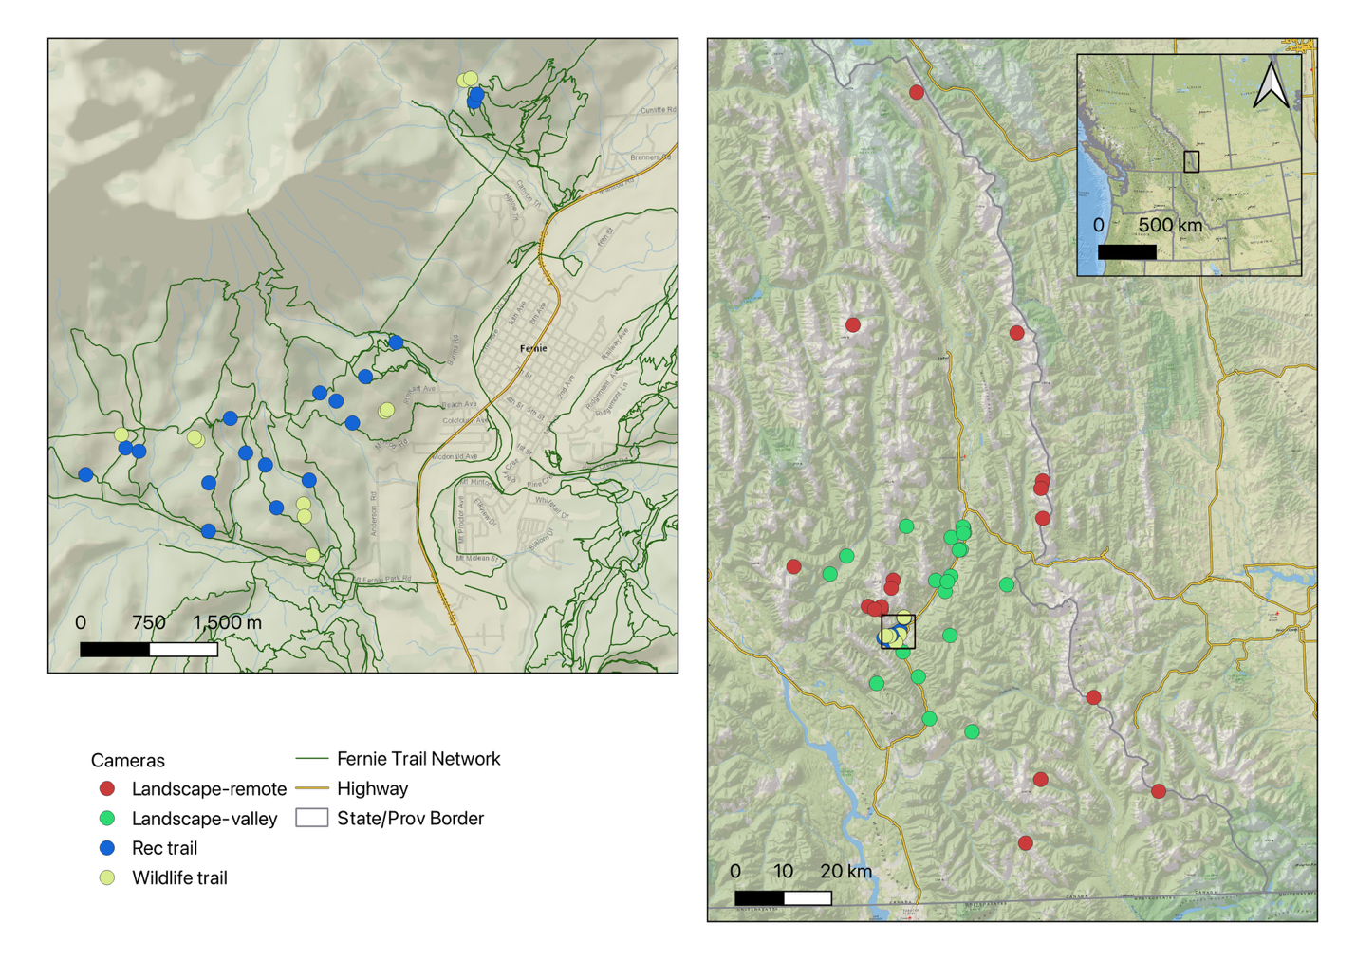

Figure 1. Map of study area near Fernie, BC, Canada in the southern Canadian Rockies. The Fernie Trail Network was assessed west of Fernie BC on the slopes of Mount Fernie and Mount Proctor with cameras on wildlife trails and recreation trails. Landscape-level comparisons were made with ancillary data from neighboring camera projects where landscape-valley were in similar habitats and a multi-use landscape to the Fernie Trail Network cameras but with less overall non-motorized recreation pressure. Landscape-remote were in areas with lower levels of human pressures as a whole compared to the other cameras, but were also in different habitats (often higher elevation) and not thus intensity of use at these cameras were not as directly comparable to other cameras. Landscape-remote cameras were used as a baseline for diel patterns in wilder areas.

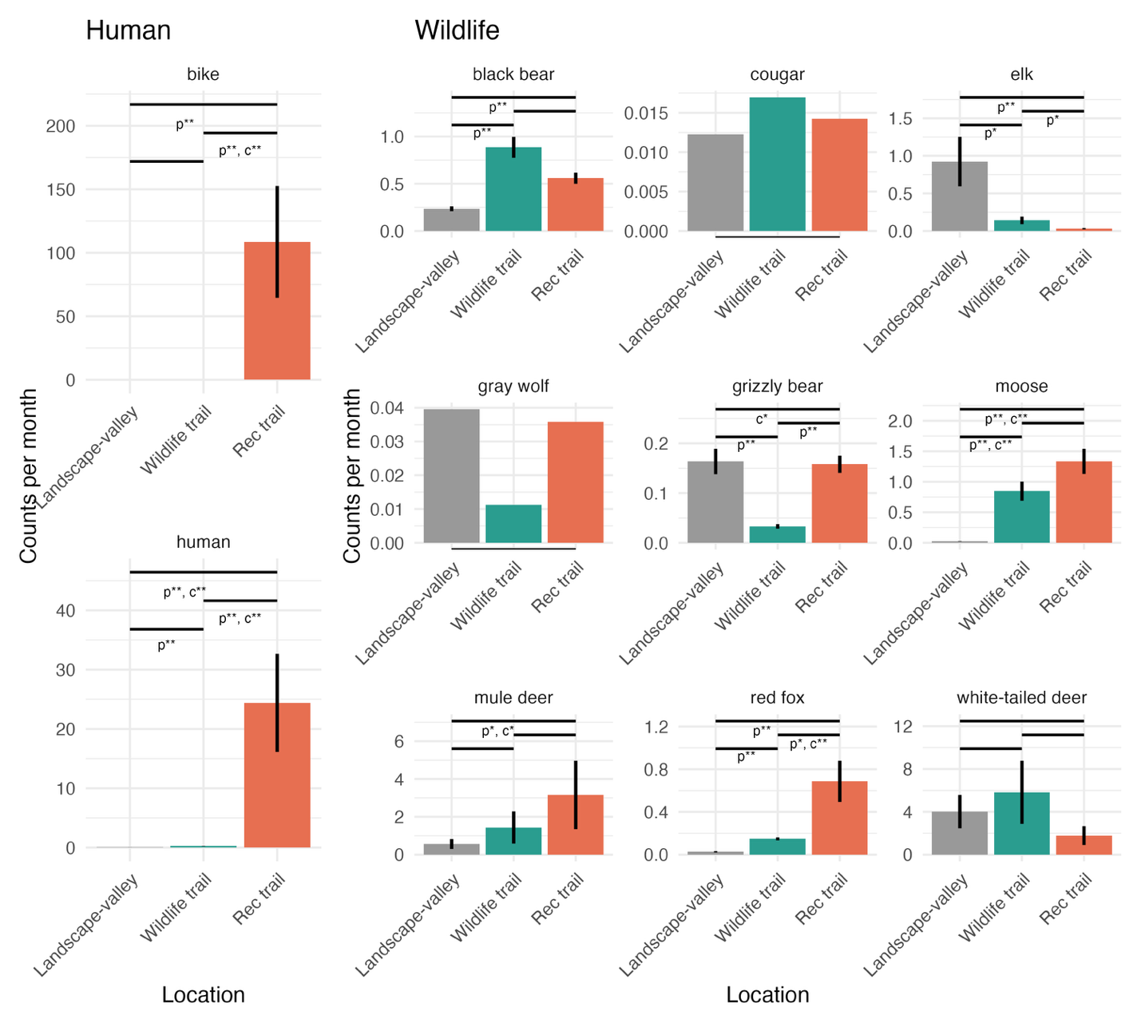

Figure 2. Intensity of use (monthly detection rate) assessments for human and wildlife groups across three zones. Results are predictions from a GLMM, and statistical significance show as * for p<0.1 and ** for p<0.05) for presence (p) and relative abundance counts (c). Horizontal Bars indicate comparison between groups. The horizontal bar spanning the full width is a combined comparison between landscape-valley and the Mt Fernie Trail network as a whole (i.e., wildlife and rec trails pooled). Cougar and gray wolf did not have sufficient detections for model convergence and were excluded from subsequent analyses.

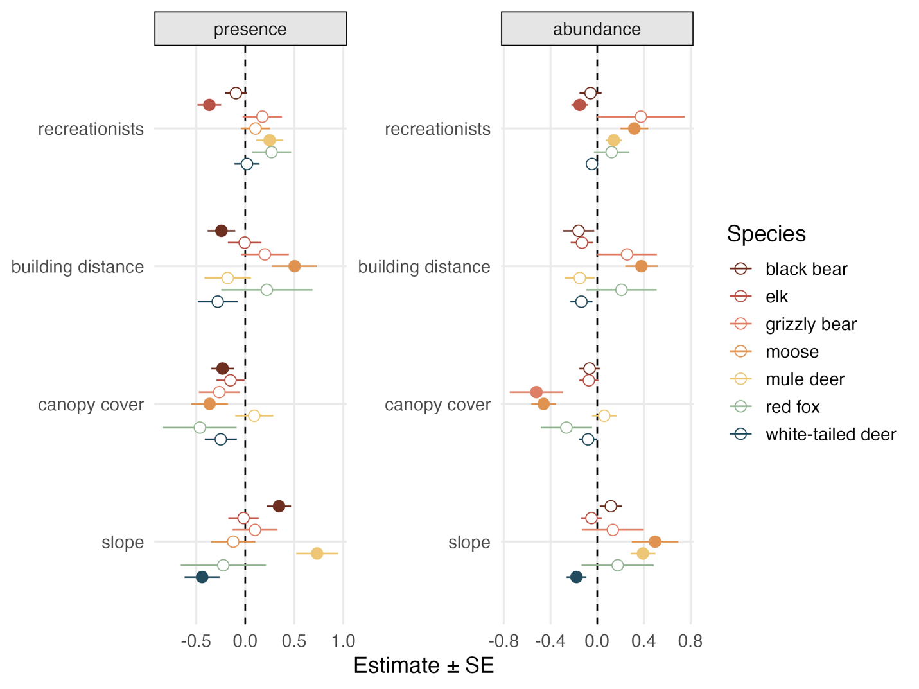

Figure 3. Influence of the number of recreationists on wildlife detections by species on recreation trails in the Fernie Trail Network. Ancillary habitat variables included to control for additional variation and compare magnitude of response. Filled dots signify statistical significance at p<0.1.

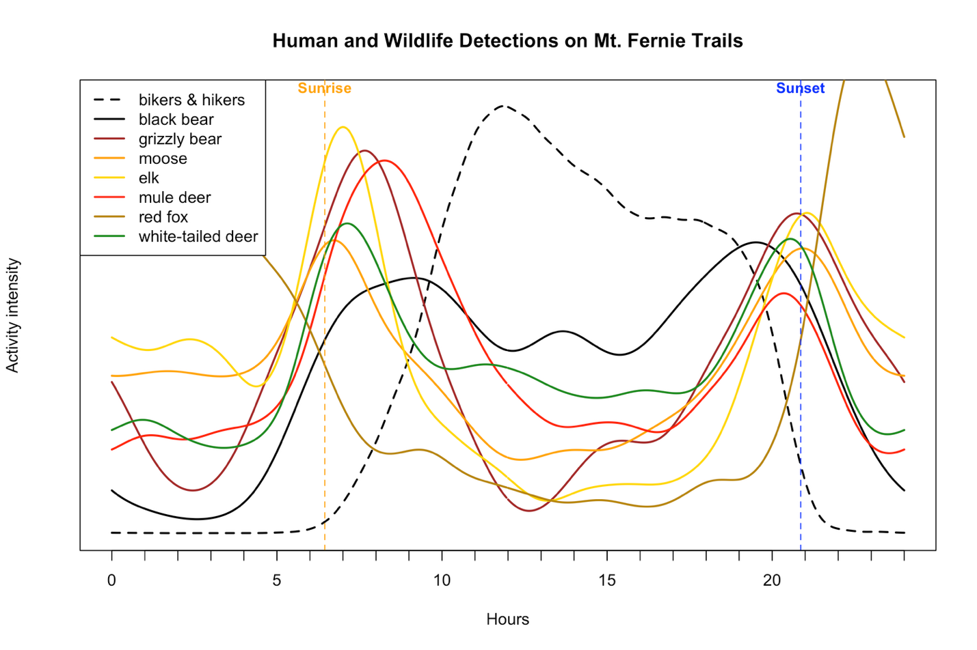

Figure 4. Diel patterns of wildlife and human recreation on recreation trails in the Fernie Trail Network.

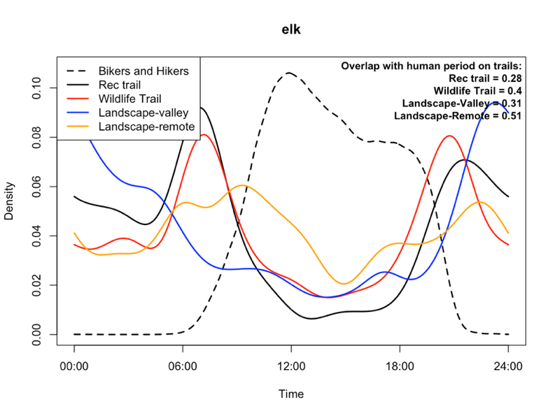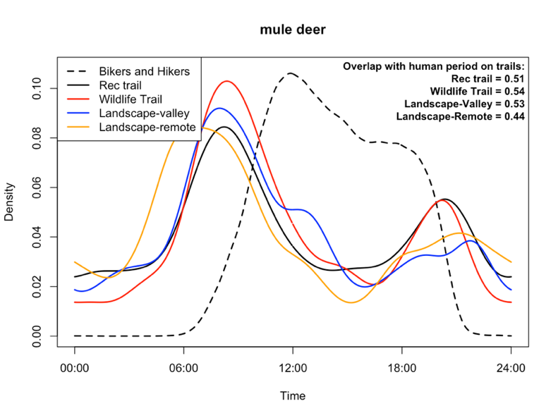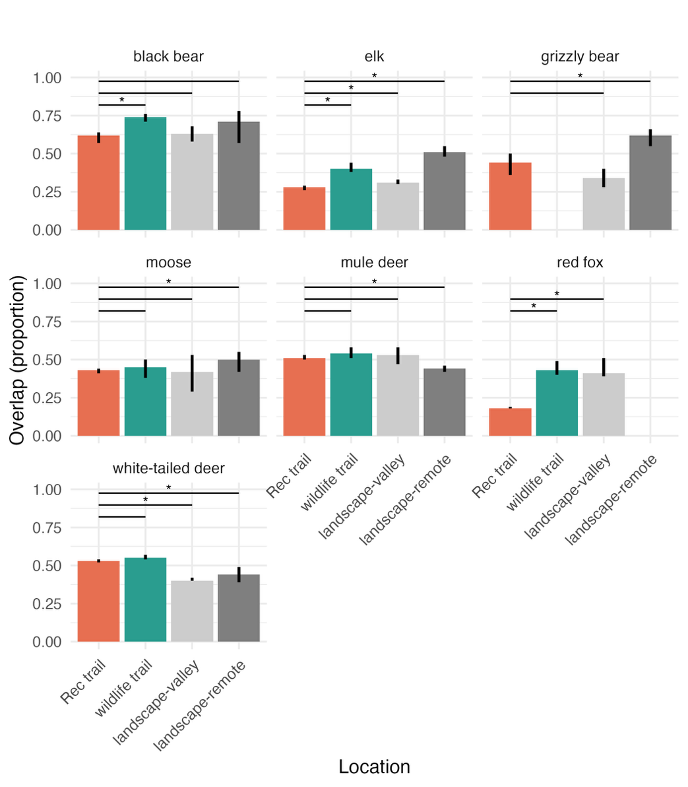

Figure 5. ## Ill make this into some sort of paneled figure## A) Comparison of recreation, wildlife, and larger landscape diel patterns for mule deer which show little diel changes across context, B) Comparison of recreation, wildlife, and larger landscape diel patterns for elk that show more daytime activity in remote areas, C) average overlap with peak recreation time from recreation trails between trail types for all species and areas.

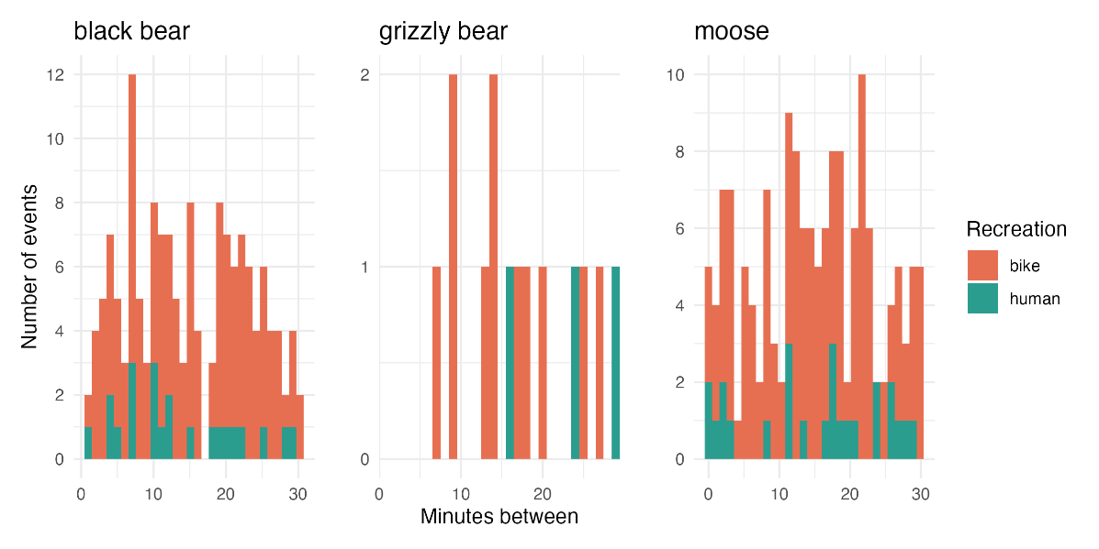

Figure 6. Near encounters between recreationists and three species of wildlife that can be dangerous to people. A) Example sequence showing bikers detected 2 minutes before and 5 minutes after a black bear on a single track trail, and B) histogram of minutes between recreationists and select wildlife species between 2021-2024.

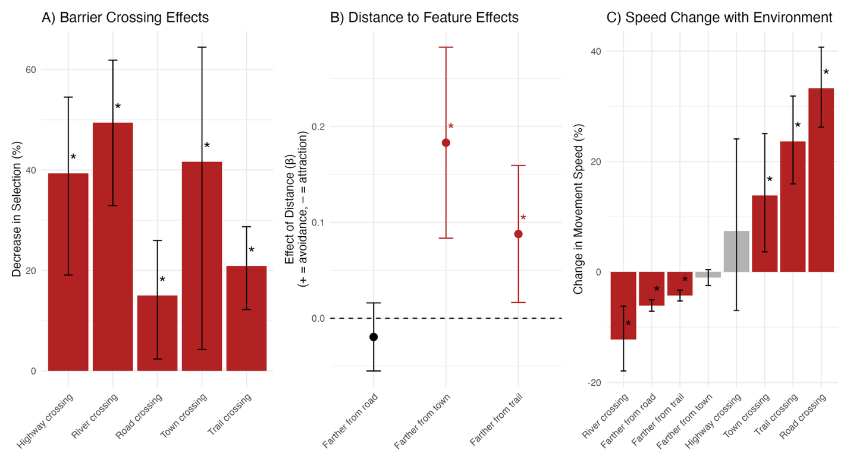

Figure 7. Integrated step selection results for grizzly bears near Fernie, BC. Response to human features shown A)decrease in selection for crossing various human features, B) effect of distance to human features. Note highway not included here due to covariance with distance to town, and C) change in movement speed in various contexts.

Table 2. Summary of recreation effects across scales and species.

|  |  |  |  |  |  |
| --- | --- | --- | --- | --- | --- |
| Selection Order | 3rd | | | 4th |  |
| Species | Response to trail network at landscape scale | Fine scale use of trails vs nearby wildlife trail | Use of single track trails with increasing recreational pressure | diel patterns on trails when people are active | Overall effect |
| Black bear | selection | neutral | neutral | avoidance | Landscape selection, fine scale avoidance/coexistence |
| Elk | avoidance | avoidance | avoidance | avoidance | Landscape avoidance, fine scale avoidance |
| Grizzly bear | avoidance | selection | neutral | avoidance | Landscape avoidance, fine scale coexistence |
| Moose | selection | neutral | selection | avoidance | Landscape selection, fine scale coexistence |
| Mule deer | selection | neutral | selection | neutral | Landscape selection, fine scale coexistence |
| Red fox | selection | selection | neutral | avoidance | Landscape selection, fine scale coexistence |
| White-tailed deer | neutral | neutral | neutral | selection | Landscape neutral, fine scale coexistence |

**Discussion**

Our study revealed that large mammal responses to non-motorized recreation in the Southern Canadian Rockies varied considerably among species, spatial scales, and behavioral metrics. Elk and grizzly bears showed avoidance of recreation at landscape and trail scales, whereas black bear, moose, mule deer, white-tailed deer, and red fox exhibited tolerance or behavioral adaptations such as diel shifts in activity. The goal of our study was to add to the growing body of literature on wildlife responses to recreational pressure and provide wildlife managers with locally relevant information to inform decisions, given previous research documented substantial species and context-specific responses to recreation (e.g., (Naidoo and Burton 2020, Miller et al. 2020, Procko et al. 2022, Granados et al. 2023, Jordan et al. 2025)).

Overall our hypothesis of strong and negative responses to recreation across species was rejected. Instead, and perhaps inconveniently for management, we observed variable and scale-dependent responses in several species. Elk, for example, exhibited avoidance of recreational areas at both broad (third-order) and fine (fourth-order) scales, suggesting that recreation may displace individuals from otherwise suitable habitat. Grizzly bears showed moderate landscape-scale avoidance of trail networks in GPS and camera data, but appeared to select for recreational trails rather than wildlife trails as travel corridors when moving through the trail network. In contrast, red foxes and other smaller carnivores did not show strong spatial avoidance but shifted their activity patterns to avoid humans temporally. It is likely that landscape-scale avoidance may be more indicative of demographic consequences such as reduced abundance due to loss of habitat, whereas diel behavioral shifts may reflect a more flexible, potentially less costly strategy of coexistence.

The variation in responses among species likely reflects both intrinsic traits, such as body size, trophic position, and anti-predator strategies, and extrinsic factors including recreation intensity, trail design, and predictability of human presence. Conceptual frameworks such as the “landscape of fear” (Brown et al. 1999), “risk-disturbance hypothesis” (Frid and Dill 2002), and the “human shield hypothesis” (Berger 2007) have been proposed to explain these patterns. The landscape of fear framework suggests that animals perceive and respond to spatial variation in predation risk, often avoiding areas they associate with danger—even if those areas contain valuable resources (Brown et al. 1999). Building on this, the risk-disturbance hypothesis posits that wildlife treat human disturbance as a form of predation risk, leading to anti-predator behaviors such as avoidance, increased vigilance, or altered activity patterns in areas used by people (Frid and Dill 2002). Because some wildlife avoid people, the human shield hypothesis proposes that some prey species may benefit from human presence by using areas near people as refuges from natural predators, who themselves avoid humans (Berger 2007). Empirical results provide mixed support for these hypotheses in explaining the variation among species and scales in response to recreation. Multi-species analyses often show some species had positive responses to recreation (Naidoo and Burton 2020, Procko et al. 2022, Fennell et al. 2023, Granados et al. 2023), suggesting the risk-disturbance hypothesis does not explain recreation effects as whole. Support for the landscape of fear and human shield also remain mixed with cases of predator and prey selecting for recreation trails (Granados et al. 2023), but others showing some support for avoidance of recreation trails by large predators and selection by prey (Procko et al. 2022, Fennell et al. 2023).

Our findings provide additional insights. Prey species showed mixed responses to recreation with clear avoidance by elk and selection by mule deer and moose, suggesting that there is not widespread support for the landscape of fear or risk-disturbance hypotheses. We had limited data to fully assess the human shield hypothesis, however the one large predator, grizzly bear, that we had sufficient data for did appear to avoid the area due to recreation pressure. Limited data on cougar and wolves limited our ability to assess the response of the full large predator community but the anectodical evidence we had showed cougars detected at similar levels within the trail network compared to the surrounding landscape and perhaps some avoidance by wolves. Regardless, because the primary prey of these large carnivores did not show consistent selection or avoidance of the area the human shield hypothesis is not an explanation for the responses of all species in the Fernie trail network.

The response of elk to recreation was among the most consistent and negative of all species in our study. Elk were significantly less likely to occur within the trail network compared to the broader landscape, and within the trail network, they were less likely to use trails than adjacent off-trail areas. When using recreation trails, elk were more likely to use trails with fewer recreational users—the only species with this response. These patterns suggest that recreation may displace elk from otherwise suitable habitat, consistent with other studies showing elk sensitivity to human activity (e.g., Procko et al. 2024, Jordan et al. 2025). Elk avoided daytime periods on recreation trails more than they do in remote areas and wildlife trails within the Fernie trail network. However, elk generally had low use of daytime periods on recreational trails, wildlife trails, and the landscape-valley cameras compared to landscape-remote cameras suggesting the avoidance of daytime on the recreation trails may not solely be due to recreation effects and may be a response to additional human pressures such as towns, roads, or hunting pressure. Overall the strong response of elk to recreation in our study and others seems to juxtapose with concurrent observations of elk becoming a nuisance in human-dominated areas such as agricultural fields and even in towns (Wilmers and Levi 2013, Guthrie 2020, Rutherford et al. 2025). Resolving this juxtaposition was not a focus of our study but clearly demonstrates the multiple competing pressures that elk are responding to in a multi-use landscape. In the case of agricultural conflicts, the reduced prevalence of hunters and predators on working ranches paired with productive forage results in dense congregations of elk. Human presence thus does not always produce negative responses in elk, and when human presence also provides productive habitat and mortality reduction elk can be found in great numbers. Elk likely avoid recreation trails because the trade-off of being disturbed by recreationists is not offset by benefits such as better forage and there is not sufficient predator or hunter avoidance of these areas.

Grizzly bears showed a more complex response to non-motorized recreation. At a broad scale, GPS data indicated moderate avoidance of the Mt. Fernie trail network relative to the surrounding valley landscape. Within the network, however, camera data showed grizzly bears were more likely to use single-track recreation trails than adjacent wildlife trails, but overall the use of the trails within the Mt Fernie network (wildlife and rec) was lower than the surrounding landscape. This apparent selection for recreation trails compared to wildlife trails within the trail network may reflect efficient travel along predictable corridors, which is consistent with the step selection analysis that shows bears moving faster when using the trail network. The overall low detection rates within the network and moderate avoidance of high-use zones suggest that trail use by grizzly bears is limited to periods or areas with lower human activity. This dual pattern of broad-scale avoidance and localized, functional trail use is consistent with a risk-management strategy in which bears minimize overlap with people while exploiting the linear features for movement when safe to do so. Similar to elk, grizzly bears were more nocturnal within the Fernie trail network and landscape-valley trails than the landscape-remote cameras suggesting human effects beyond just recreation are causing bears to alter their behaviour. The iSSA analysis provides important context of bears’ response to other competing human pressures. While bears avoided the trail network, they more strongly avoided settled areas such as the area around the town of Fernie, thus the effects detected from cameras within the Fernie trail network must be considered with cumulative effects of additional pressures of the town, highway, and roads in mind. Bears avoided crossing the recreation trails and resource roads, but not nearly as much as they avoided crossing the town, or highway.

From a management perspective, our results indicate that non-motorized recreation can influence wildlife habitat use and behavior, but effects are species- and context-specific. It is our perspective that overall, the effects of recreation were moderate to low for the species we considered, especially considering the currently compact footprint of the trail network relative to the surrounding landscape. Of the species considered, elk and grizzly bear were the primary species that showed negative effects, with elk showing the most consistent and strong responses. Mitigating the negative effects to elk and grizzly bear could be accomplished by concentrating recreation in high-use, predictable areas such as those around existing towns. Such an approach reduces the spatial extent of disturbance because the towns themselves already have a buffer of impacts around them and provides low use refugia for more sensitive species in the areas outside the concentrated recreation areas. Seasonal or spatial closures may be warranted in areas that overlap with key habitats or during vulnerable periods such as bighorn sheep lambing areas or bear dens. To protect the crepuscular periods that wildlife often begin to use as pressure increases during the day it is recommended to concentrate recreation pressure during the daylight hours between 10 am and 7 pm. The very low rate of near encounters between recreationists and wildlife, particularly large carnivores, suggests that current patterns of recreation do not pose a high risk of conflict, though proactive measures such as signage, concentrating use during the day, and education remain important. The animals within the Fernie trail network are often avoiding human recreation at some scale, likely to reduce any negative effects on themselves, so seeing as the animals are doing what they can to coexist with recreation it’s important for recreationists to do what they can to coexist with wildlife.

While it is well documented that time in nature is good for people, the effects of recreation on wildlife continues to be an evolving area of research that struggles to find consistently strong effects across contexts and species. There is also substantial variation in the perspectives of the public and recreationists on the effects of recreation on wildlife, which ranges from benign to substantial impacts. Recreationists perceive any impacts as often due to other recreation types and rarely their preferred type of recreation (i.e., hikers blame mountain bikers and horseback riders, and vice versa, (Taylor and Knight 2003)). In a landscape of murky results, polarized stakeholders, and exponentially increasing recreational pressure landscape managers are clearly left in a challenging position. Some of the challenges in finding consistent effects of recreation may be a result of layers of ecological complexity that true context-dependency, or could be a result of generally small true effect sizes and confounding variables creating variable results. Our study relied on observational data, which limits our ability to infer causality. Although we used a multi-scale design and integrated data from camera traps and GPS telemetry, confounding factors such as habitat quality, habituation, topography, and detectability can never be perfectly accounted for. As noted by others (Jordan et al. 2025), stronger inference requires experimental approaches, such as Before-After-Control-Impact (BACI) designs, temporary trail closures, or controlled recreation manipulations. While such studies present logistical and ethical challenges, they are critical for establishing causal links between recreation and wildlife responses and for identifying thresholds of acceptable use. We encourage land managers, trail alliances, and researchers to collaborate to set up BACI experiments prior to new trails being built. Such an experiment would ideally have multiple years of before and after data and include measurements directly on the trail and nearby within the buffer of potential recreation effects (100-500 m). Such an approach would provide strong evidence of the effect of recreation on wildlife. Replicating these experiments across gradients of recreation disturbance such as new trails within existing networks through to trails within a less disturbed landscape, as well as across differing recreation use volumes would eventually provide the critical information to assess the context-dependent nature of recreation.

In conclusion, non-motorized recreation influences wildlife behavior and space use in complex, scale-dependent ways. Some species demonstrate behavioral plasticity that may facilitate coexistence, while others appear more sensitive to human presence and may be displaced from preferred habitats. Managing recreation to maintain predictable use patterns, minimize trail proliferation, and retain undisturbed refugia will be essential to support diverse wildlife communities in multi-use landscapes. Future experimental and demographic studies will further help quantify the long-term impacts of recreation and to inform adaptive management strategies.

**Acknowledgements**

This study was made possible due to financial support from the Liber Ero Fellowship, British Columbia Conservation Trust Foundation, TC Energy, and the Wilburforce Foundation. Thanks to Melanie Dickie for providing feedback on an earlier version of the manuscript. BP and FTA review?

**References**

Avgar, T., J. R. Potts, M. A. Lewis, and M. S. Boyce. 2016. Integrated step selection analysis: bridging the gap between resource selection and animal movement. Methods in Ecology and Evolution 7:619–630.

Beery, S., D. Morris, and S. Yang. 2019, July 15. Efficient Pipeline for Camera Trap Image Review. arXiv.

Berger, J. 2007. Fear, human shields and the redistribution of prey and predators in protected areas. Biology Letters 3:620–623.

Bratman, G. N., C. B. Anderson, M. G. Berman, B. Cochran, S. de Vries, J. Flanders, C. Folke, H. Frumkin, J. J. Gross, T. Hartig, P. H. Kahn, M. Kuo, J. J. Lawler, P. S. Levin, T. Lindahl, A. Meyer-Lindenberg, R. Mitchell, Z. Ouyang, J. Roe, L. Scarlett, J. R. Smith, M. van den Bosch, B. W. Wheeler, M. P. White, H. Zheng, and G. C. Daily. 2019. Nature and mental health: An ecosystem service perspective. Science Advances 5:eaax0903.

Brown, J. S., J. W. Laundré, and M. Gurung. 1999. The Ecology of Fear: Optimal Foraging, Game Theory, and Trophic Interactions. Journal of Mammalogy 80:385–399.

Costello, C. M., S. I. Cain, R. M. Nielson, C. Servheen, and C. C. Schwartz. 2013. Response of American black bears to the non-motorized expansion of a road corridor in Grand Teton National Park. Ursus 24:54–69.

Dymit, E., R. Garcia‐Anleu, and T. Levi. 2025. Avoidance–attraction ratios incorrectly characterize behavioral interactions with camera trap data. Ecology 106:e70134.

Fennell, M., C. Beirne, and A. C. Burton. 2022. Use of object detection in camera trap image identification: Assessing a method to rapidly and accurately classify human and animal detections for research and application in recreation ecology. Global Ecology and Conservation 35:e02104.

Fennell, M. J. E., A. T. Ford, T. G. Martin, and A. C. Burton. 2023. Assessing the impacts of recreation on the spatial and temporal activity of mammals in an isolated alpine protected area. Ecology and Evolution 13:e10733.

Forman, R. T. T., and L. E. Alexander. 1998. Roads and Their Major Ecological Effects. Annual Review of Ecology and Systematics 2:207-231+C2.

Frid, A., and L. M. Dill. 2002. Human-caused Disturbance Stimuli as a Form of Predation Risk. Conservation Ecology 6:art11.

Gaynor, K. M., C. E. Hojnowski, N. H. Carter, and J. S. Brashares. 2018. The influence of human disturbance on wildlife nocturnality. Science 360:1232–1235.

Granados, A., C. Sun, J. T. Fisher, A. Ladle, K. Dawe, C. Beirne, M. S. Boyce, E. Chow, N. Heim, M. Fennell, J. Klees van Bommel, R. Naidoo, M. Procko, F. E. C. Stewart, and A. C. Burton. 2023. Mammalian predator and prey responses to recreation and land use across multiple scales provide limited support for the human shield hypothesis. Ecology and Evolution 13:e10464.

Greene, G. A. 2021. FIRE-RESILIENT ECOSYSTEMS: FIRE EXCLUSION AND SELECTIVE HARVESTING DEGRADE DRY FORESTS IN BRITISH COLUMBIA. University of British Columbia, Vancouver, BC.

Guthrie, J. W. 2020. Understanding and Preventing Elk Use of Agriculture Crops. M.S., University of Idaho, United States -- Idaho.

Johnson, D. H. 1980. The Comparison of Usage and Availability Measurements for Evaluating Resource Preference. Ecology 61:65–71.

Jordan, S. E., T. R. Ganz, T. K. Rutherford, M. J. Blocker, C. T. Domschke, F. L. Klasner, E. H. Masters, T. A. Morgan, D. R. Ratajczak, E. C. Teige, and S. K. Carter. 2025. Effects of nonmotorized recreation on ungulates in the western United States—A science synthesis to inform National Environmental Policy Act analyses. US Geological Survey.

Laliberte, A. S., and W. J. Ripple. 2004. Range Contractions of North American Carnivores and Ungulates. BioScience 54:123.

Lamb, C. 2025a. Flathead and Elk Valley Mountain Pass Monitoring: Year 2. Page 44. Yaq?it ?a·knuq?i ’it and the Province of British Columbia, East Kootenay, BC.

Lamb, C., E. Chow, and M. Jones. 2025. Reconnecting the Rockies:BC 2020-2024 Progress Report. Page 61. British Columbia Ministry of Transportation and Transit.

Lamb, C., L. Smit, B. McLellan, L. M. Vander Vennen, and M. Proctor. 2022. Considerations for furbearer trapping regulations to prevent grizzly bear toe amputation and injury. Wildlife Society Bulletin 46:e1343.

Lamb, C. T. 2025b. Tourism Fernie Recreation Monitoring of Heiko’s Trail: 2024 Progress Report. Page 48. Tourism Fernie.

Lamb, C. T., L. Smit, G. Mowat, B. McLellan, and M. Proctor. 2023. Unsecured attractants, collisions, and high mortality strain coexistence between grizzly bears and people in the Elk Valley, southeast British Columbia. Conservation Science and Practice 5:e13012.

Miller, A. B., R. Kays, and Y.-F. Leung. 2020. Wildlife response to recreational trail building: An experimental method and Appalachian case study. Journal for Nature Conservation 56:125815.

Monz, C. A., C. M. Pickering, and W. L. Hadwen. 2013. Recent advances in recreation ecology and the implications of different relationships between recreation use and ecological impacts. Frontiers in Ecology and the Environment 11:441–446.

Muff, S., J. Signer, and J. Fieberg. 2020. Accounting for individual-specific variation in habitat-selection studies: Efficient estimation of mixed-effects models using Bayesian or frequentist computation. Journal of Animal Ecology 89:80–92.

Naidoo, R., and A. C. Burton. 2020. Relative effects of recreational activities on a temperate terrestrial wildlife assemblage. Conservation Science and Practice 2:e271.

Poole, K. G., C. T. Lamb, S. Medcalf, and L. Amos. 2024. Migration, movements, and survival in a partially migratory elk (Cervus canadensis) population. Conservation Science and Practice n/a:e13128.

Procko, M., R. Naidoo, V. LeMay, and A. C. Burton. 2022. Human impacts on mammals in and around a protected area before, during, and after COVID ‐19 lockdowns. Conservation Science and Practice 4.

Procko, M., S. G. Winder, S. A. Wood, M. Sevigny, D. G. Collins, M. Alves, and L. R. Prugh. 2024. Quantifying impacts of recreation on elk (Cervus canadensis) using novel modeling approaches. Ecosphere 15:e4873.

Rutherford, K., D. Visscher, and C. C. S. Clair. 2025r. Jurisdictional scan of strategies for mitigating elk-agriculture conflict. University of Alberta, Edmonton, Alta.

Taylor, A. R., and R. L. Knight. 2003. Wildlife Responses to Recreation and Associated Visitor Perceptions. Ecological Applications 13:951–963.

Thomsen, J. M., R. B. Powell, and C. Monz. 2018. A Systematic Review of the Physical and Mental Health Benefits of Wildland Recreation. Journal of Park and Recreation Administration 36:123–148.

Urhan, U., K. Platjouw, P. P. de Vries, E. Serrano Davies, and K. van Oers. 2025. Associations between human non-motorised recreational activity on nest box occupation, exploratory behaviour and breeding success in a passerine bird. Journal of Avian Biology 2025:e03281.

Whittington, J., M. Hebblewhite, R. W. Baron, A. T. Ford, and J. Paczkowski. 2022. Towns and trails drive carnivore movement behaviour, resource selection, and connectivity. Movement Ecology 10:17.

Wiedmann, B. P., and V. C. Bleich. 2014. Demographic responses of bighorn sheep to recreational activities: A trial of a trail: Bighorn Sheep Responses to Recreation. Wildlife Society Bulletin 38:773–782.

Wilmers, C. C., and T. Levi. 2013. Do irrigation and predator control reduce the productivity of migratory ungulate herds? Ecology 94:1264–1270.

Wisdom, M. J. 2005. The Starkey Project: a synthesis of long-term studies of elk and mule deer. Lawrence, Kansas: Alliance Communications Group. 252 p.

Wisdom, M. J., H. K. Preisler, L. M. Naylor, R. G. Anthony, B. K. Johnson, and M. M. Rowland. 2018. Elk responses to trail-based recreation on public forests. Forest Ecology and Management 411:223–233.

**##OTHER**

We calculated the species avoidance ratio to estimate whether wildlife delayed their use of trails following use by hikers, bikes, or motorized vehicles. We primarily replicated the approach used by (Naidoo and Burton 2020) where we calculated the avoidance ratio and then used a Bayesian generalized linear mixed model to assess the effect by species and overall for each type of recreation. We made some additional changes, including following the recommendations from (Dymit et al. 2025) to use the T2b/T1 parameterization which in our case uses the uninterrupted time between a wildlife species and recreationist where no other species or recreationists intervened as T2b, and T1 as the uninterrupted time between a recreationist and a wildlife species.

[**https://academic.oup.com/jmammal/pages/author-guidelines**](https://academic.oup.com/jmammal/pages/author-guidelines)

[**https://www.sciencedirect.com/journal/journal-for-nature-conservation/publish/guide-for-authors**](https://www.sciencedirect.com/journal/journal-for-nature-conservation/publish/guide-for-authors)

**free journals: https://search.scifree.se/crkn?term=Ecology+and+Conservation&payment=Included+in+Publisher+Agreement**